**Register No.:**1518102072

**Exercise No:** 5

**Date:** 16.10.2020

**Aim:**

To print the missing characters to make string pangram.

**Program:**

a=input()

a=set(a.strip())

a.remove(chr(32))

b="abcdefghijklmnopqrstuvwxyz"

b=set(b)

b=b.difference(a)

b=list(b)

b.sort()

print("".join(b))

**Link:**

[**http://103.53.53.18/mod/vpl/forms/submissionview.php?id=235&userid=1686**](http://103.53.53.18/mod/vpl/forms/submissionview.php?id=235&userid=1686)

**Output:**

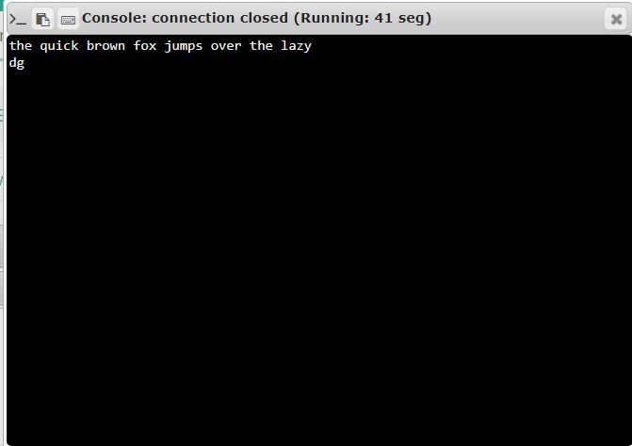

**Result:**

Thus, the code is executed successfully and the output is verified.